3/16/2022

**NEW PHASE ACCOMMODATION HALLS FOR “THE COLLEGE”**

**Executive Summary**

The Board of College finally come to conclude that to built new buildings for the accommodations to students, flats for professors with advanced modern felicities and new construction methods which makes the buildings to be sustainable in nature in line with sustainable energy development strategy and to reduce the energy consumption and CO2 emissions during the construction and operational phase of development. A modern pavilion which includes dinning and cocking space which will be very helpful to conduct college events.

The College has approached the best architects in the city and explained the scope of the project and the desired requirements such as comfortable, durable and modern addition to the campus that is functional, cost effective, elegant and sustainable. The project is extensive and ambitious and will replace existing, outdated accommodation with a suite of new buildings and amenities and with the latest energy conservation systems like roof-mounted solar cells and air source heat exchangers. The buildings with the historic importance will remain.

The finance to the project for the construction and operation is arranged by the college by the combination of private bonds and fundraising from their extensive and successful alumnae base. A 35M bond due for repayment in 45 years was issued January 2021 with 3.37% of interest rate (i.e., 1.1795M per year to be paid monthly).

An overview of construction plan with total budget, cashflow and NPV is included in this executive report.

The college board finally after all the proposals has planned to start the project in September 2022 and finish it by the end of July 2025.

**Introduction:**

The proposed project is for the development of a residential hall for 'The College' for the client Master and Fellows. Additionally, the concept includes a Sports Pavilion and an Assembly Hall. The proposed structure comprises of twelve additional buildings designated A1, A2, A3, B1, B2, C1, C2, D1, D2, D3, the Sports Pavilion, and Assembly Hall, as illustrated in the architect sketch plan Figure 1. The residence halls are being erected to provide additional housing for 'The College's' students. Encouraged by city planners because of its compatibility with their master plan. The Residence Halls are designed to provide suitable housing for students attending 'The College.' Some older, out-of-date lodgings are removed to make way for new residence halls equipped with all necessary amenities.

The college is located on the eastern side of the sports field. The project is proposed to be built with sustainable building strategy.

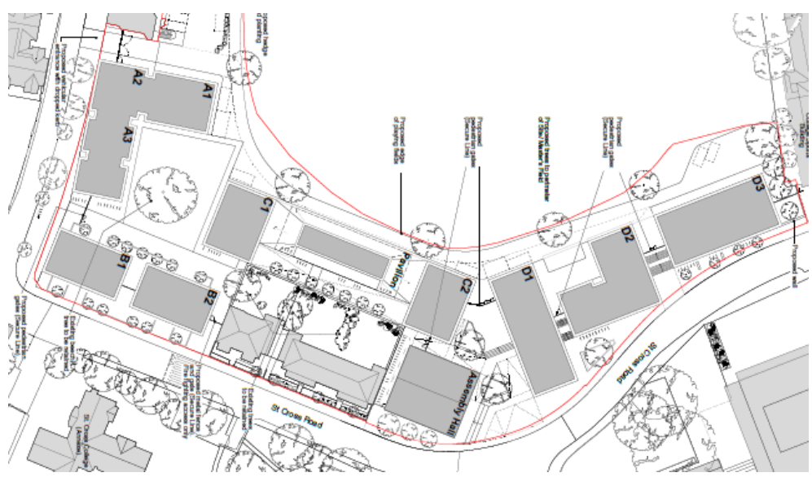

Fig 1. Architect sketch plan

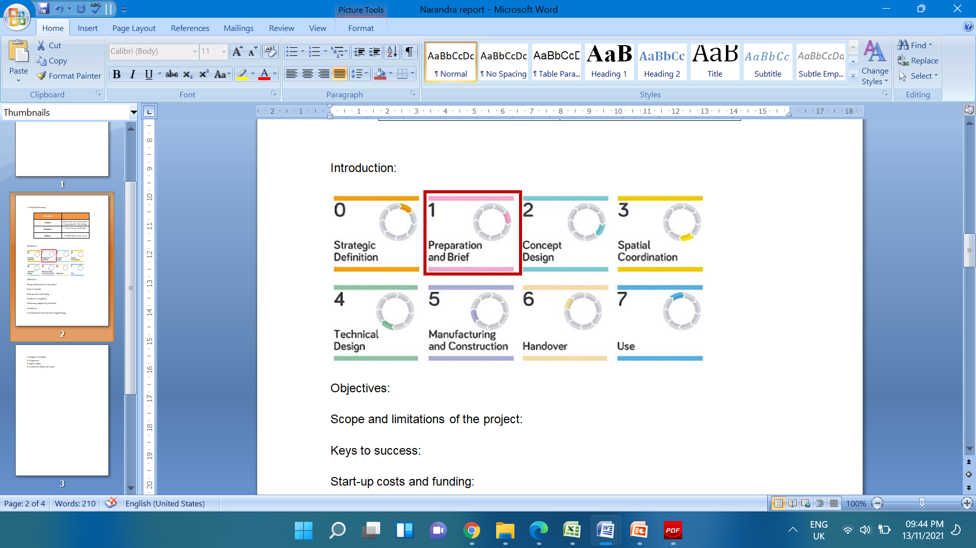

Figure 2: RIBA plan of works 2020

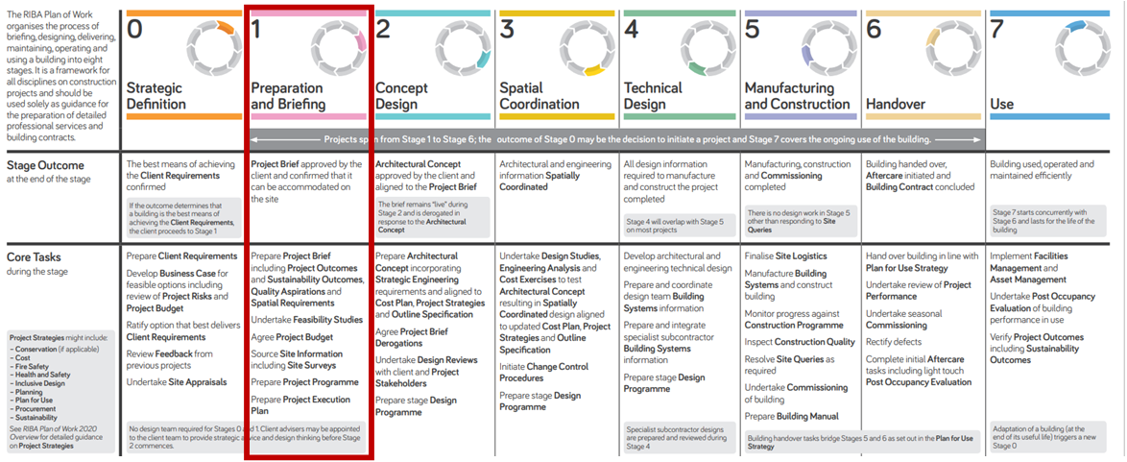

Figure 3: RIBA 2020 - Stage 1

**CONSTRUCTION OVERVIEW**

The proposed construction of Residence Halls for the 'The College' building is scheduled to begin in September 2022 and be finished in July 2025. The construction procedure is phased, utilising all modern construction techniques. All building operations will be conducted in accordance with the Health and Safety at Work Act 1974. The project brief is written with all of the project's outcomes, sustainability needs, quality objectives, and spatial requirements specified by the client, and it is submitted to the client's Masters and Fellows for approval. Additionally, the project adheres to CDM rules (Construction Design and Management Regulations).

The following are some of the precautions used to ensure the site's health and safety:

* All construction activities are carried out by trained specialists and personnel.
* CDM laws and regulations apply to every aspect of the project.
* Personal protective equipment (PPE) regulations are adhered to, and all employees are adequately outfitted.
* Regulations governing manual handling operations will be followed.
* As development is progressed, noise levels at work will be monitored to ensure that they do not bother nearby inhabitants on the project site.

**OBJECTIVES**

The project's primary purpose is to create modern, comfortable, durable, and aesthetically beautiful residence halls for 'The College's' students. The building is proposed to be constructed using sustainable construction techniques and energy-efficient systems such as rooftop solar cells and heat exchangers. The building's architecture incorporates a Cross Laminated Timber (CLT) frame, wall, and floor system.

* Along with the primary purpose, the secondary objective is to provide: construct an energy-efficient structure that will minimise the city's ongoing energy and water use, hence reducing greenhouse gas emissions such as CO2.
* Provide a pleasant learning environment for pupils
* Identify and resolve all maintenance issues, including electrical, mechanical, plumbing, mechanical, and structural.
* Complete the project within the budget constraints imposed by the client.

**DEVELOPMENT DESCRIPTION & ENERGY STRATEGY**

The building is equipped with all energy-efficient renewable energy sources for energy generation in order to ensure the building's future viability. The following are the suggested sustainable and energy-efficient measures for the 'The College' building:

* The building will be designed to maximise natural light and ventilation by using vertical and horizontal louvers in the appropriate directions. Additionally, by adding ceiling windows, the pupils receive natural light and ventilation.
* The structures' wall and roof framing systems are made of Cross Laminated Timber. Additionally, they are mounted on steel reinforced concrete basements connected by structural steel stairwells.
* Due to their resistance to large racking and compressive forces, CLT panels are particularly cost effective for multi-story and long-span diaphragm applications. Due of their lighter weight than concrete or steel, they can help reduce foundation costs. Additionally, CLT elements can be combined with other building materials, such as glulam beams, to complete the architecture's design, style, and flexibility.
* Design flexibility: Raising the thickness of a CLT panel allows for greater spans with fewer internal support elements.
* They have a good thermal performance and are extremely energy efficient. They are economical.
* Environmental benefits: Because CLT is composed of wood harvested from sustainably managed forests, it possesses a number of environmental benefits in addition to its superior thermal properties. Wood is the only recyclable basic building material. Natural and renewable resource, as well as life cycle analysis. In terms of embodied energy, wood constantly surpasses steel, air pollution, and concrete.
* The properties and performance of CLT include the following:
* Walls with a high axial load capacity resist buckling better.
* Considerably higher stiffness/strength-to-mass ratio
* Exhibits superior shear strength, allowing it to withstand horizontal stresses.
* Soft tales are less susceptible to the consequences of soft storey failure than other sorts of stories.
* Platform-based structural systems
* 20:30 floor-to-depth ratios; 30:40 roof-to-depth ratios
* Cross Laminated Timber (CLT) was used for the interior of the housing halls.
* Photovoltaic panels are installed on the roofs of the resident halls, supplying hot water and heating and electric energy to the units 24 hours a day.
* A rainwater collection tank should be erected to enable the water to be used in the home. Passive solar heating can be achieved by installing solar panels on a sloping façade or roof.
* Decreased embodied energy through the use of long-lasting and durable local materials, on-site dug resources, and recycled components. By utilising cement substitute materials such as ground granulated blast-furnace slag (GGBS), pulverised fuel ash, and so on, as well as calcined clay and powered limestone, we may significantly reduce carbon emissions (CO2).
* Solar panels and solar thermal systems on residence halls are depicted in Figure 4.
* The interior of the building will be painted with solvent-free paints. Roof slabs can be coated with a solar reflective cool roof coating. Not only will this paint completely waterproof and thermally seal the roof slabs, but it will also improve their appearance.
* Carbon cure concrete should be explored for future projects. Carbon cure concrete is created during the production process by infusing CO2 into the concrete.
* The CO2 then reacts with calcium ions to form calcium carbonate ions. This not only strengthens the concrete, but also offsets the CO2 emissions that are frequently generated.

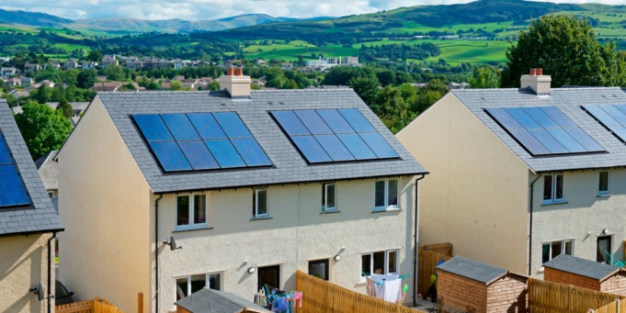

Figure 4: Solar panels and solar thermal systems on Residence Halls.

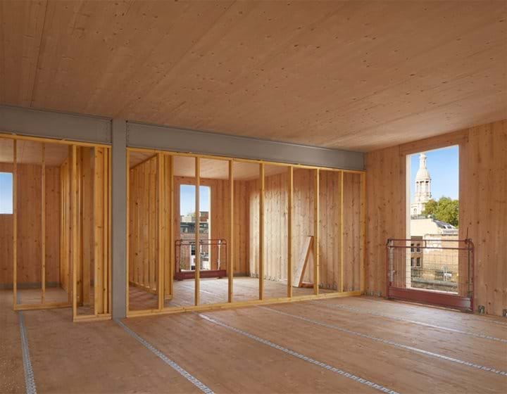 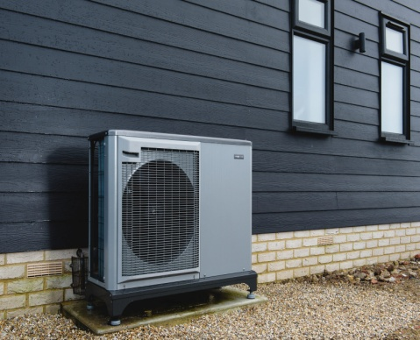

Figure 5: Cross Laminated Timber for interior and ground source heat pump

**Sustainability:**

* Sustainable construction is defined as the use of renewable materials materials and resources in the construction process. When building a new structure, consideration must be made to reduce waste and energy consumption while also protecting the natural environment in the direct proximity of the structure.
* There are many organizations that are formed to monitor the sustainability in every aspectes of the industries. Such as BREEAM, LEAD etc
* BREEAM is an international regulatory system that generates independent third-party certification of reviews of the sustainable development performance of individual buildings, communities, and infrastructure projects. It was established in 1992.

**Future proofing:**

Future-proofing a structure entails a thorough examination of possible future scenarios:

* What changes might occur during the building's lifetime?
* What are the chances of those changes occurring?
* How significant would the ramifications of such a transformation be?
* How much does it cost to future-proof against that change?

This evaluation process should be ongoing, involving the client, designers, suppliers, contractors, and end users, and should be comparable to how risk assessments are conducted. Assessment is a highly complex process, and there is a risk that a building will adopt unsustainable future-proofing measures:

The situation may not occur. The solution chosen to deal with the issue may fail or be implemented incorrectly. Unexpected circumstances may render the solution unsuccessful. This means that, while the literature frequently implies that future proofing a facility is always advantageous and naturally 'environmental,' future-proofing against the incorrect situations might be a substantial waste of resources.

**COSTS AND FUNDING**

The money and costs associated with the project's construction come from the following sources, as outlined below by 'The College':

* Rent for student and staff housing
* Conferences, for example
* Profitability of investments
* Funds raised through private placement bonds and alumnae fundraising.
* Income from bond money dividends.

The report focuses on explaining a cash flow model developed for the project in order to estimate the project's monthly cumulative cash flow. Positive cash flow is defined as money that enters the project account, such as bonds and rent, whereas negative cash flow is defined as money that leaves the project account.

The following assumptions are made:

* Construction expenses are approximated based on monthly payments made during the project's various phases.
* Due to the project's staged construction, portions of the project are completed and rented to allow for the construction of the other blocks.
* Include revenue from room rentals and bonds issued during the construction period.

**Budget:**

The construction estimation has been calculated based on the area and the cost per Sq. Meter and shown in the figure 6.

* Risk allowance was considered to be 9% of the total construction value to overcome the unforcen events that might occur during the time of construction.
* For the professionals who has been involved in the project like surveyors, engineers, designers and consultants the fees was considered to be 13% of the value of the Construction
* 15% of the construction cost was considered for the sustainability and future proofing.

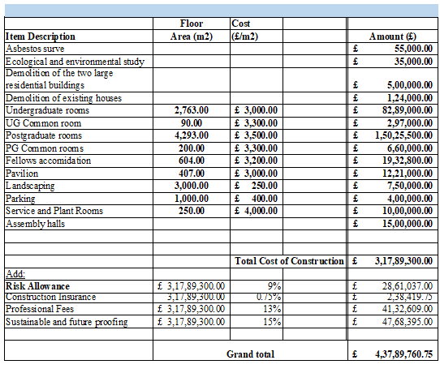

Figure 6. Overall budget of the project

In addition to above budget shown The College also needs Maintenance cost show in the table attached below.

The expenditures of maintenance are gradually added to the budget when the structures are built. The maintenance fees increases by 3% per year after reaching £200000, the base cost for the completed development.

The base cost of £200000 will be achieved in the first five years as shown below.

|  |  |  |  |
| --- | --- | --- | --- |
| **Year** | **Maintenance Costs (£)** | **Year** | **Maintenance Costs (£)** |
| 1 | 25,000 | 24 | 350,701 |
| 2 | 50,000 | 25 | 361,222 |
| 3 | 100,000 | 26 | 372,059 |
| 4 | 150,000 | 27 | 383,221 |
| 5 | 200,000 | 28 | 394,717 |
| 6 | 206,000 | 29 | 406,559 |
| 7 | 212,180 | 30 | 418,756 |
| 8 | 218,545 | 31 | 431,318 |
| 9 | 225,102 | 32 | 444,258 |
| 10 | 231,855 | 33 | 457,586 |
| 11 | 238,810 | 34 | 471,313 |
| 12 | 245,975 | 35 | 485,452 |
| 13 | 253,354 | 36 | 500,016 |
| 14 | 260,955 | 37 | 515,017 |
| 15 | 268,783 | 38 | 530,467 |
| 16 | 276,847 | 39 | 546,381 |
| 17 | 285,152 | 40 | 562,772 |
| 18 | 293,707 | 41 | 579,656 |
| 19 | 302,518 | 42 | 597,045 |
| 20 | 311,593 | 43 | 614,957 |
| 21 | 320,941 | 44 | 633,405 |
| 22 | 330,570 | 45 | 652,408 |
| 23 | 340,487 |  |  |

Table 1. Maintenance cost for 45 years

**Project Schedule:**

* This construction phase was planned to be initiate on 1st September 2022 and estimated to complete by 22nd of July 2025 so that The College can start the new academic year with the new phase buildings.
* The new phase was designed phase wise by demolishing existing structures and construction the new structures. So that students can be provided with at-least one accommodation without causing any problems to students as well as financial implications to the college board.
* The detailed schedule of new phase of the accommodation halls for the college has been prepared as a gant-chart to give an overview of the phase wise start and finish of the new structures.
* This gant chart provides the information regards the start and end of the each building and provides the percentage of work has completed to the required date based on calculations.
* The entire 'The College' structure is expected to be finished in July 2025. The location is prepared by demolishing the existing fellows dwellings, garages, and walls. Later, blocks 'A' and 'B' are constructed. A phased construction procedure is envisioned, with the building's 'A' and 'B' blocks constructed first. When completed, the blocks will house students who are currently housed in two big residential structures.
* Later, the land is prepared by demolishing the two huge residential structures on the northern side. Blocks 'C' and 'D', as well as the Pavilion and Assembly hall, are now under development. The blocks of buildings A, B, C, and D. As illustrated in Figure 7, the existing trees in and around the building area must be conserved throughout construction.

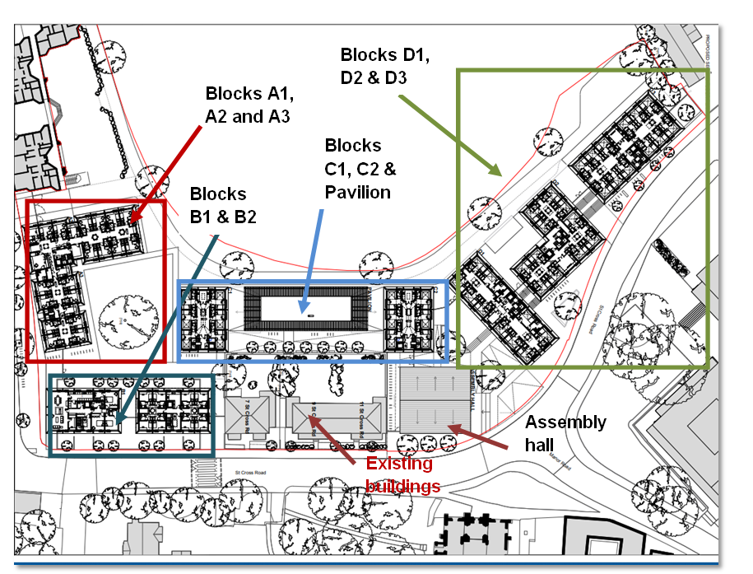

Figure 7: Proposed construction site with existing trees to be retained.

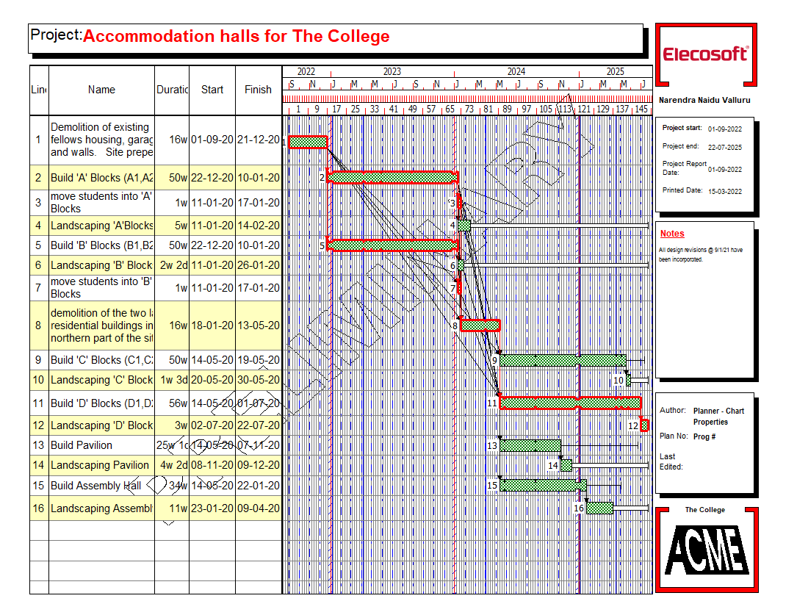

Fig 8. Gant Chart for the schedule of Accommodation halls for the college

**Organisation chart:**

The College

Architects

Project Management Team

**Construction Company**

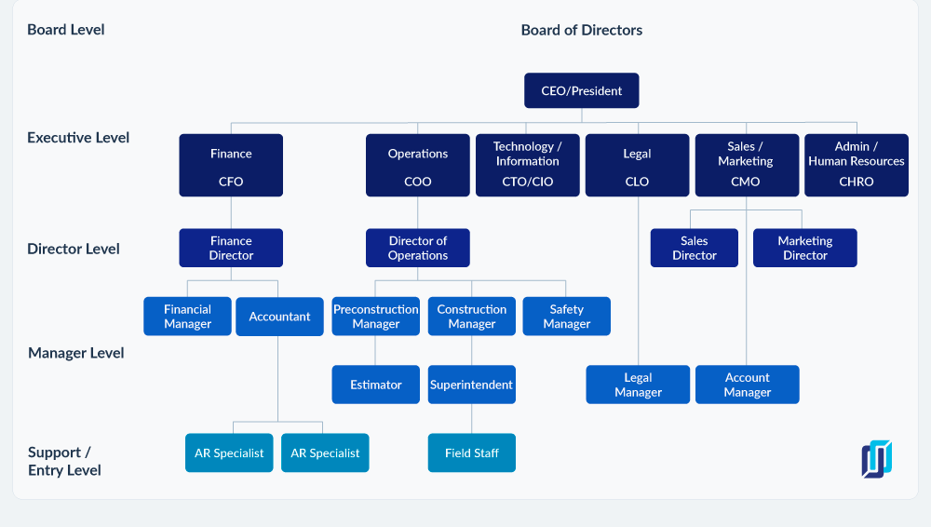

**Cashflow:**

The Cash flow was estimated by including all the inflows and out flows.

Cash Outflow:

* Construction Cost of the project.
* Maintenance cost for the project for both old and new structures.
* Interest that have to be paid for the bond

Cash Inflow:

* Rents collected from the existing accommodation and the new built structures for under graduate, postgraduate room and etc.
* Fundraising activities.
* Events organized.
* Profits that came from the investing of the bonds.

The detailed cashflow in the excel sheet has been attached below.

From the mid of Year 4 to year 19 as there will be no revenue, Fundraising activities are done to generate revenue to pay contractors.

**NPV (Net Present Value):**

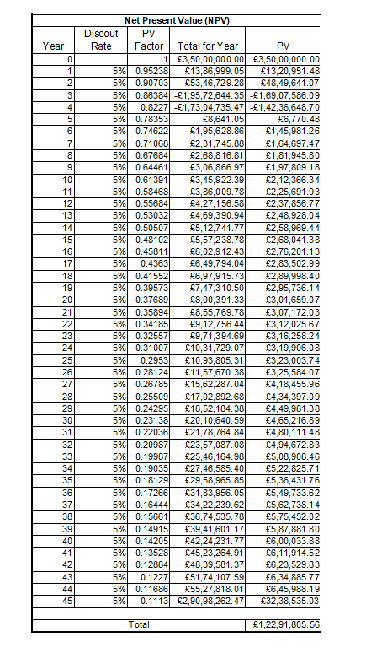 Table 2 Net Present Value

NPV helps in determining the current value of future cashflow. From the Table 2 the net present value is £12291805.56 which is positive. Therefore, client can get good returns from investment to make this project successful.

**Conclusion:**

After analysing the results using the cashflow and financial analysis, the college can continue for construction process to build residential halls for students. They will be able to repay bond money at the end of 45th year. During in between construction process fund raising to be done to pay contractors.

As the college has future proofing concept it will be able to accommodate more students in future when there is increase in demand.

References:

Alarcón, L.F. and Mardones, D.A., 1998, August. Improving the design-construction interface. In *Proceedings of the 6th Annual Meeting of the International Group for Lean Construction* (pp. 1-12).

Chua, D.K.H., Kog, Y.C., Loh, P.K. and Jaselskis, E.J., 1997. Model for construction budget performance—Neural network approach. *Journal of Construction Engineering and Management*, *123*(3), pp.214-222.

Kagioglou, M., Cooper, R., Aouad, G. and Sexton, M., 2000. Rethinking construction: the generic design and construction process protocol. *Engineering, construction and architectural management*.

Love, P.E., Liu, J., Matthews, J., Sing, C.P. and Smith, J., 2015. Future proofing PPPs: life-cycle performance measurement and building information modelling. *Automation in Construction*, *56*, pp.26-35.

Musarat, M.A., Alaloul, W.S. and Liew, M.S., 2021. Impact of inflation rate on construction projects budget: A review. *Ain Shams Engineering Journal*, *12*(1), pp.407-414.

Oke, A.E., Aigbavboa, C.O. and Semenya, K., 2017. Energy savings and sustainable construction: examining the advantages of nanotechnology. *Energy Procedia*, *142*, pp.3839-3843.

Portney, K.E., 2015. *Sustainability*. MIT Press.

Pun, K.F., Hui, I.K. and Lee, W.K., 2001. An EMS approach to environmentally‐friendly construction operations. *The TQM Magazine*.

Thiele, L.P., 2016. *Sustainability*. John Wiley & Sons.

Tulenheimo, R., 2015. Challenges of implementing new technologies in the world of BIM–Case study from construction engineering industry in Finland. *Procedia Economics and Finance*, *21*, pp.469-477.

Vasconcelos, B.M., Soeiro, A.A.V. and Junior, B.B., 2011. Prevention through Design: Guidelines for designers. *Coordina2011*.

Velez-Pareja, I., 2005. Construction of cash flows revisited. *Available at SSRN 784486*.

Ye, S. and Tiong, R.L., 2000. NPV-at-risk method in infrastructure project investment evaluation. *Journal of construction engineering and management*, *126*(3), pp.227-233.